
COMSATS University Islamabad, Lahore Campus

Department of Computer Engineering

Final Year Project (FYP) Proposal

Project Title | IntelliSafe: Real-Time Working Site Safety Monitoring using Edge Computer Vision.

Project Supervisor | Dr. Ikramullah Khosa.

Group Members |  | Name |  | Reg. ID | Email Address
Group Members | i |  | Muhammad Ahmad | FA23-BCE-113 | fa23-bce-113@cuilahore.edu.pk
Group Members | ii |  | Uzair | FA23-BCE-098 | fa23-bce-098@cuilahore.edu.pk

Comments about the Group and the Project Scope:
IntelliSafe monitors a work site in real time. It detects five classes: worker, helmet, vest, fire, and smoke. The compliance engine checks each worker against those rules, raises debounced alerts, and saves image evidence. Events are published over MQTT to a backend that stores them, shows them on a supervisor dashboard, and produces compliance reports.
This is a two member group. Uzair owns perception: the dataset, the YOLOv8n model, the compliance engine, evidence capture, and the handoff dictionary. Muhammad Ahmad owns the platform: MQTT, the backend services, the dashboard, and Jetson deployment. Both members share integration, testing, and the final demonstration.
Muhammad Ahmad  First student’s signature | Dr. Ikramullah Khosa  Supervisor’s signature
Uzair  Second student’s signature | Dr. Ikramullah Khosa  Supervisor’s signature

Department of Computer Engineering
COMSATS University Islamabad
LAHORE Campus – PAKISTAN

Table of Contents

1. Abstract 3
2. Introduction 4
2.1 Overview 4
2.2 Problem Statement 4
2.3 Objectives 5
2.4 Project Mapping on SDGs 5
2.5 Deliverables at the End of the FYP 5
3. Methodology 6
3.1 Proposed Approach 6
3.2 System Diagram 6
4. Timeline 7
5. References 8

1. Abstract
IntelliSafe is an edge-based safety monitoring system for industrial and construction work sites. A camera connected to an NVIDIA Jetson Nano runs a single YOLOv8n detector that finds workers, their personal protective equipment (helmet and vest), and fire or smoke. A compliance engine links each helmet and vest to the worker wearing it, checks the safety rules, and keeps a rolling compliance score. When a violation continues, it sends one alert instead of repeating it on every frame, and it saves an image as evidence.
These events are published over MQTT to a backend that stores them, streams them live to a supervisor web dashboard, and generates PDF compliance reports. Occasional manual inspection is replaced with continuous, evidence-based monitoring. Violations are caught as they happen, and management gets data to act on before an accident occurs.

2. Introduction

2.1 Overview
The International Labour Organization estimates about 3 million work-related deaths and 395 million non-fatal injuries worldwide each year [1]. Construction and manufacturing account for a large share of that harm, and a substantial part is linked to missing personal protective equipment or to hazards, such as fire and smoke, that go unnoticed on the floor. Safety practice on many sites is still a human supervisor walking periodic rounds. Coverage has gaps between rounds, attention drops over a long shift, an incident is later reconstructed from memory, and management cannot see which zone, shift, or PPE item is the recurring failure.
Edge computers can now run real-time object detection beside the camera, so full video does not have to leave the site [6]. PPE detection with deep learning is already demonstrated in the research literature [2], [3], and the YOLO family provides a unified real-time detector suited to this setting [4], [5]. The missing piece on a real site is the system around the model: per-worker compliance decisions, hazard events, durable delivery of alerts, stored evidence, historical analytics, and reports a supervisor will actually use.
IntelliSafe closes that gap. The camera sees workers and hazards. The compliance engine decides whether the helmet and vest rules are met. The platform alerts the supervisor, stores the evidence, and keeps the trend. A camera-based system sees the work area, decides compliance, alerts on violations, and records the result for analysis and reporting.

2.2 Problem Statement
Design and implement a low-cost edge computer-vision platform that monitors a work site in real time, detects PPE non-compliance and fire or smoke, and delivers alerts, image evidence, and compliance analytics to site supervisors.
Four failures of current practice define the problem. Inspections are periodic, so a missing helmet between rounds is invisible. One supervisor cannot watch every worker for every hour of a shift. When something goes wrong, there is often no time-stamped image. There is also no trend: a site manager cannot tell whether helmet violations are rising, or whether a particular shift is the weak point. Approved detection for this project is worker, helmet, vest, fire, and smoke.

2.3 Objectives
- Detection: Train a YOLOv8n model to detect workers, helmets, vests, fire, and smoke with good accuracy.
- Compliance engine: Link each helmet and vest to the worker wearing it, check that both are worn, keep a compliance score, raise one alert per continuing violation, and save an image as evidence.
- Edge deployment: Run the model and the compliance engine in real time on an NVIDIA Jetson Nano.
- Event delivery: Send violation and hazard events from the Jetson to the backend over MQTT.
- Backend and storage: Store events, compliance history, and evidence images in a database.
- Dashboard and reports: Show live alerts and compliance trends on a web dashboard, and generate PDF compliance reports.

2.4 Project Mapping on SDGs
The project maps to three Sustainable Development Goals
SDG | Goal | How IntelliSafe contributes
SDG 3 | Good Health and Well-being | It spots missing helmets and vests and detects fire or smoke early, so preventable injuries are less likely.
SDG 8 | Decent Work and Economic Growth | It supports safe working environments by monitoring PPE use continuously instead of relying on occasional inspections.
SDG 9 | Industry, Innovation and Infrastructure | It uses low-cost edge AI to bring real-time, evidence-based safety monitoring to industrial and construction sites.

2.5 Deliverables at the End of the FYP
- An annotated dataset and a trained YOLOv8n model for worker, helmet, vest, fire, and smoke.
- An edge application on the Jetson Nano that runs detection and the compliance engine and saves image evidence.
- An MQTT link that sends events from the Jetson to the backend.
- A backend with a database for events, compliance history, and evidence images.
- A web dashboard for live alerts and compliance trends, plus PDF compliance reports.
- Project documentation, the FYP report, and a live end-to-end demonstration.

3. Methodology

3.1 Proposed Approach
The system has two parts that meet at one fixed handoff. On the edge, a camera connected to an NVIDIA Jetson Nano runs the YOLOv8n detector and the compliance engine. The compliance engine checks each worker for a helmet and vest, raises one alert per continuing violation, and saves an image as evidence. Each result is packed into a structured event and sent over MQTT to the backend. The backend stores the events and evidence, pushes live alerts to the supervisor dashboard, and generates PDF compliance reports. The event format is agreed on at the start, so model training and backend development can go ahead in parallel. Until the Jetson is connected, a simple event simulator feeds the backend test events.
A typical PPE-detection project draws boxes on a video and stops there. IntelliSafe goes further, with per-worker compliance checks, fire and smoke alerts, stored image evidence, compliance trends, and PDF reports. Detection itself is well studied [2], [3]. The contribution of this FYP is a complete, deployable safety-monitoring system built around a small edge detector.

3.2 System Diagram
Figure 1 shows the path of one detection cycle, from the camera to the supervisor.
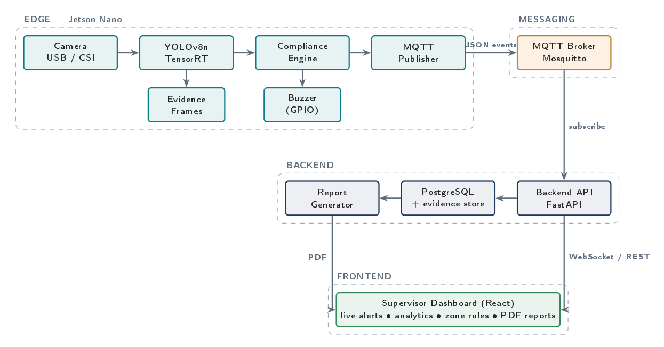
Figure 1. IntelliSafe system diagram, from the camera to the supervisor dashboard.

4. Timeline
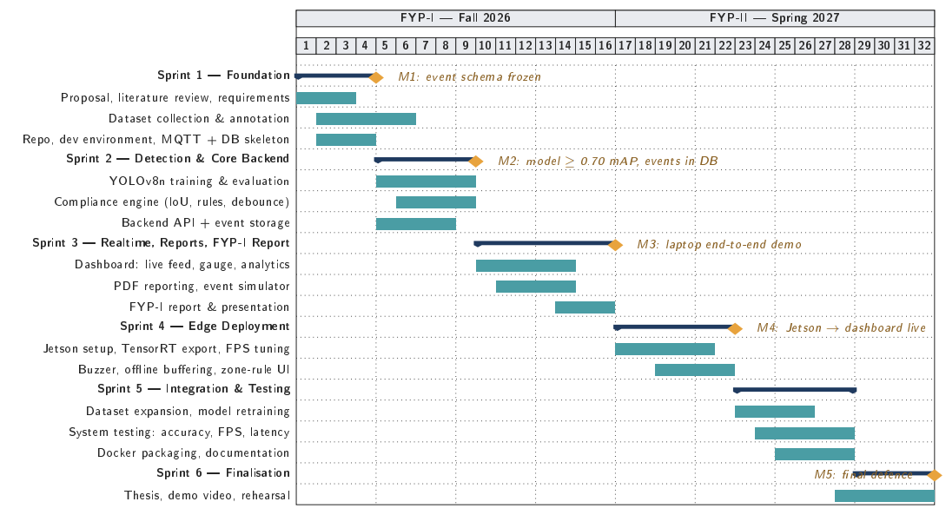
Figure 2. Project Gantt chart. FYP-I covers weeks 1–16 (Fall 2026) and FYP-II covers weeks 17–32 (Spring 2027)

5. References

[1] International Labour Organization, A Call for Safer and Healthier Working Environments. Geneva, Switzerland: ILO, 2023.
[2] N. D. Nath, A. H. Behzadan, and S. G. Paal, "Deep learning for site safety: Real-time detection of personal protective equipment," Automation in Construction, vol. 112, Art. no. 103085, 2020.
[3] Z. Wang, Y. Wu, L. Yang, A. Thirunavukarasu, C. Evison, and Y. Zhao, "Fast personal protective equipment detection for real construction sites using deep learning approaches," Sensors, vol. 21, no. 10, Art. no. 3478, 2021.
[4] J. Redmon, S. Divvala, R. Girshick, and A. Farhadi, "You only look once: Unified, real-time object detection," in Proc. IEEE Conf. Comput. Vis. Pattern Recognit. (CVPR), 2016, pp. 779-788.
[5] G. Jocher, A. Chaurasia, and J. Qiu, Ultralytics YOLOv8, 2023. [Online]. Available: https://github.com/ultralytics/ultralytics
[6] NVIDIA Corporation, Jetson Nano Developer Kit. [Online]. Available: https://developer.nvidia.com/embedded/jetson-nano
[7] P. V. A. B. de Venancio, A. C. Lisboa, and A. V. Barbosa, "An automatic fire detection system based on deep convolutional neural networks for low-power, resource-constrained devices," Neural Computing and Applications, vol. 34, pp. 15349-15368, 2022.
[8] OASIS, MQTT Version 5.0, OASIS Standard, Mar. 2019. [Online]. Available: https://docs.oasis-open.org/mqtt/mqtt/v5.0/mqtt-v5.0.html

